EXTRACTING DATA

1. Create table and insert values
Firstly, Creating the table student and inserted the values to perform the operations such as SELECT, WHERE, ORDER BY, LIMIT, LIKE, BETWEEN & AND...

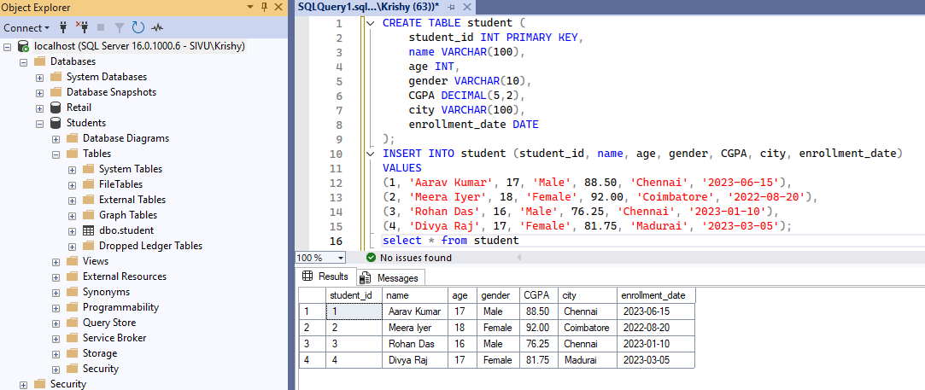

2. Select Statement

Filtering the values using various conditions by using select query with orderby

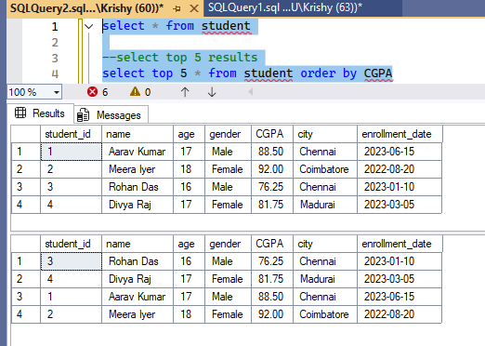
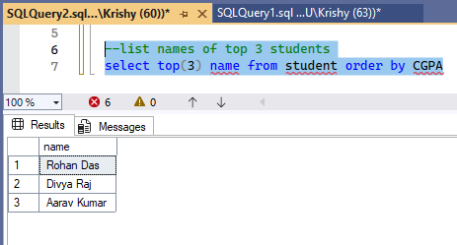

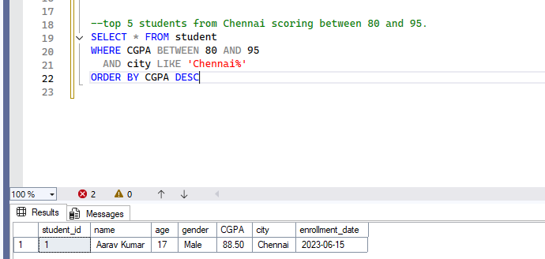

3. Where Condition

Here we see how Where clause can be used with different functions…

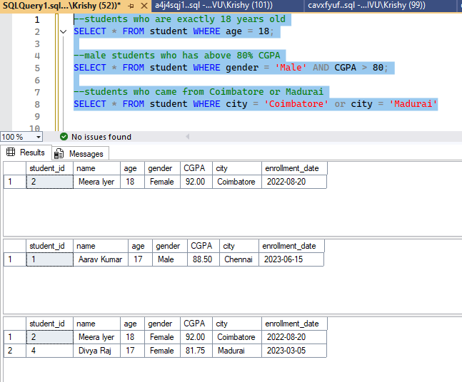

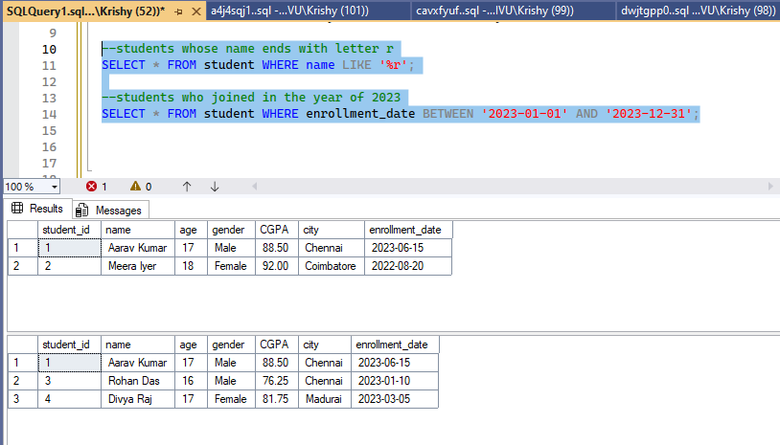
4. Limit with orderby

SQL Server does not support LIMIT. Instead, it uses the TOP keyword or OFFSET and FETCH.

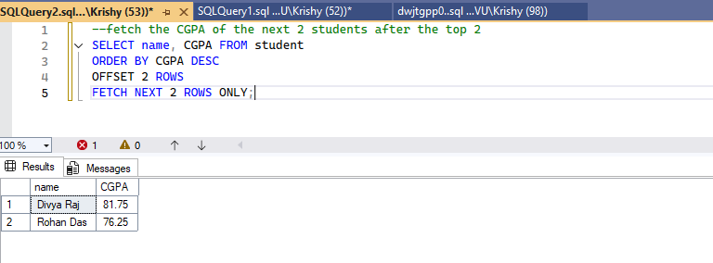

Limit will be supported by MySQL, PostgreSQL, SQLite

To get the top 3 students by CGPA:
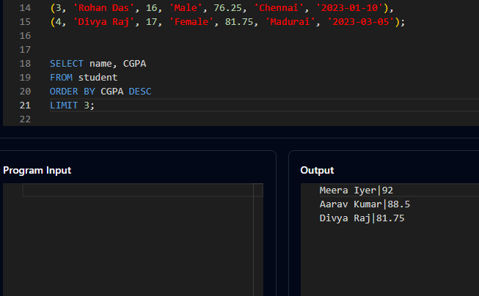

To get the next 3 after top 3 students by CGPA:

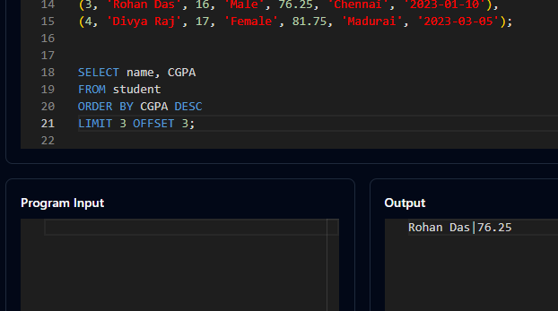

5. Distinct

Give unique entries of the record without any duplicates.

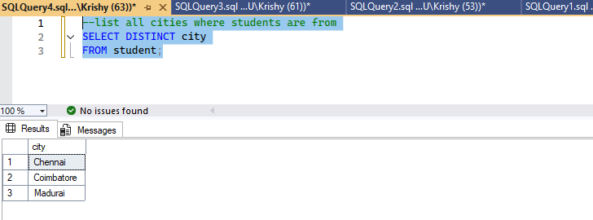

Thank you!

